School in Thailand Continues to Expand

Chugait Garmolgomut and his wife Amphorn (Fong) run schools in the city of Chiang Mai, Thailand. I recently helped Chugait and Fong open a kindergarten extension of their flourishing Ambassador Bilingual School (ABS) for grades 1-6.
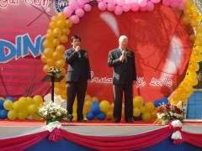
The author and Chugait Garmolgomut opening the new kindergarten at Ambassador Bilingual School in Thailand.
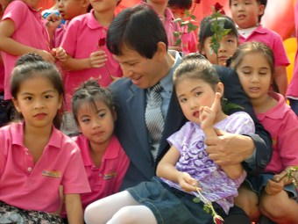
Chugait Garmolgomut with several of the school’s children.
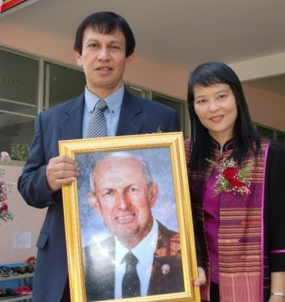
Chugait and Fong Carmolgomut with a portrait of the late Dr. Herman Hoeh, who encouraged and inspired them to start the school.

The school’s idea grew from a challenge from the late Dr. Herman L. Hoeh, who loved Thailand and all things Thai. Chugait and Fong had been raised as Buddhists. Now Christians, they wanted to reach their people with the gospel. They asked Herman Hoeh what to do, and he suggested they start a school based on true values and right living. He gave them $100 to get started.
They started a small school in their basement apartment, teaching in Thai and English. Many Thais want to learn English, as it is often a significant key to a successful career. As more students came to them, they were able to expand. ABS is the flagship of a network of bilingual schools in Northern Thailand. Chugait and Fong leased an empty five-story office building on the outskirts of Chiang Mai. They renovated it and made it into a bright school for several hundred students in grades 1-6. I helped them open the ABS two years ago. At that time, they showed me an empty, semi-derelict warehouse that stood behind the main school. “That’s where the kindergarten will be,” explained Fong.
They have now transformed the old warehouse into a sparkling kindergarten and renamed it the “Love Building”—a fitting name, since we opened the kindergarten on February 14th. Chugait asked me to say a few words to the large group of parents who had come to the opening ceremony. I told them that in the Western world, February 14 is known as Valentine’s Day, when people gave gifts to those they love. The school is also a gift of love, to the parents, the children and the future of Thailand.
The Thais are tolerant of all faiths, but the vast majority of the people remain staunchly Buddhist. Frankly, much missionary activity in Thailand goes nowhere, because the Christian message is presented in a way that is out of context with Thai culture. However, traditional values are beginning to fray as Thailand continues to modernize. ABS teaches Christianity by example, and although making converts is not the focus, Chugait and Fong have baptized dozens of people in the last few years. Today a church of about 70 meets in their home.
ABS now offers an education from kindergarten through middle school. I jokingly asked Fong, “So where are you going to build the high school?” Without hesitation, she pointed to an empty lot next door. “We’ll put it there,” she said, “if that is God’s will.”
It probably is. Psalm 127 reminds us “unless the Lord builds the house, the builders labor in vain.” It seems that the Lord is building this “house,” as the work is certainly not in vain. It is a success story that is attracting the attention of educators and missionaries in Thailand.
2012, 2016

